**DAILY ONLINE ACTIVITIES SUMMARY**

|  |  |  |  |  |  |  |  |  |
| --- | --- | --- | --- | --- | --- | --- | --- | --- |
| **Date:** | **03-06-2020** | | | | | **Name:** | **Shiza Amreen.J** | |
| **Sem & Sec** | **4th sem B sec** | | | | | **USN:** | **4AL18CS078** | |
| **Online Test Summary** | | | | | | | | |
| **Subject** | | **Object Oriented Concepts** | | | | | | |
| **Max. Marks** | | **30** | | **Score** | | | **17** | |
| **Certification Course Summary** | | | | | | | | |
| **Course** | **Python for Machine Learning** | | | | | | | |
| **Certificate Provider** | | | **GreatLearning** | | **Duration** | | | **5 Hours** |
| **Coding Challenges** | | | | | | | | |
| **Problem Statement:** **Write a code segment in java to swap two numbers using call by object reference.** | | | | | | | | |
| **Status: Completed** | | | | | | | | |
| **Uploaded the report in Github** | | | | | **yes** | | | |
| **If yes Repository name** | | | | | **Lockdown_Coding** | | | |
| **Uploaded the report in slack** | | | | | **Yes** | | | |

Online Test Details:

Today I had OOC IA-3, I have attended the internal and got 17 out of 30.

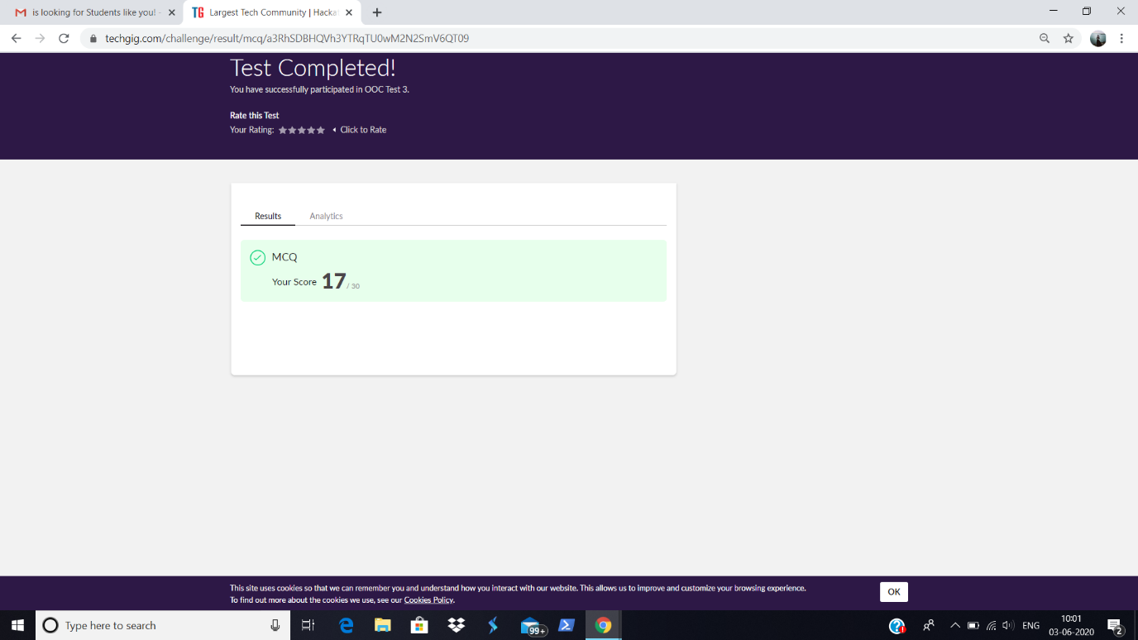

Certification Course Details:

Today I have completed the Python for Machine Learning course in GreatLearning, and Successfully, got the Certificate.

Certificate:

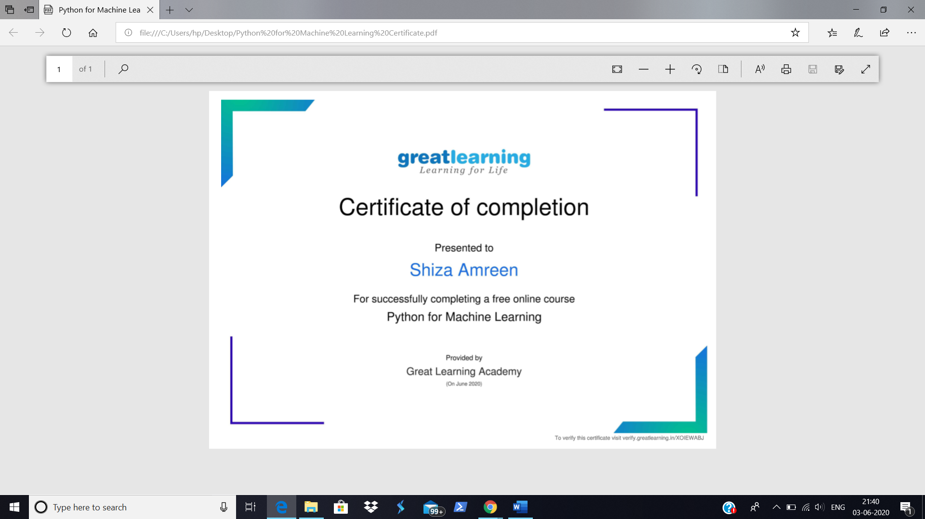

<https://olympus1.greatlearning.in/course_certificate/XOIEWABJ>

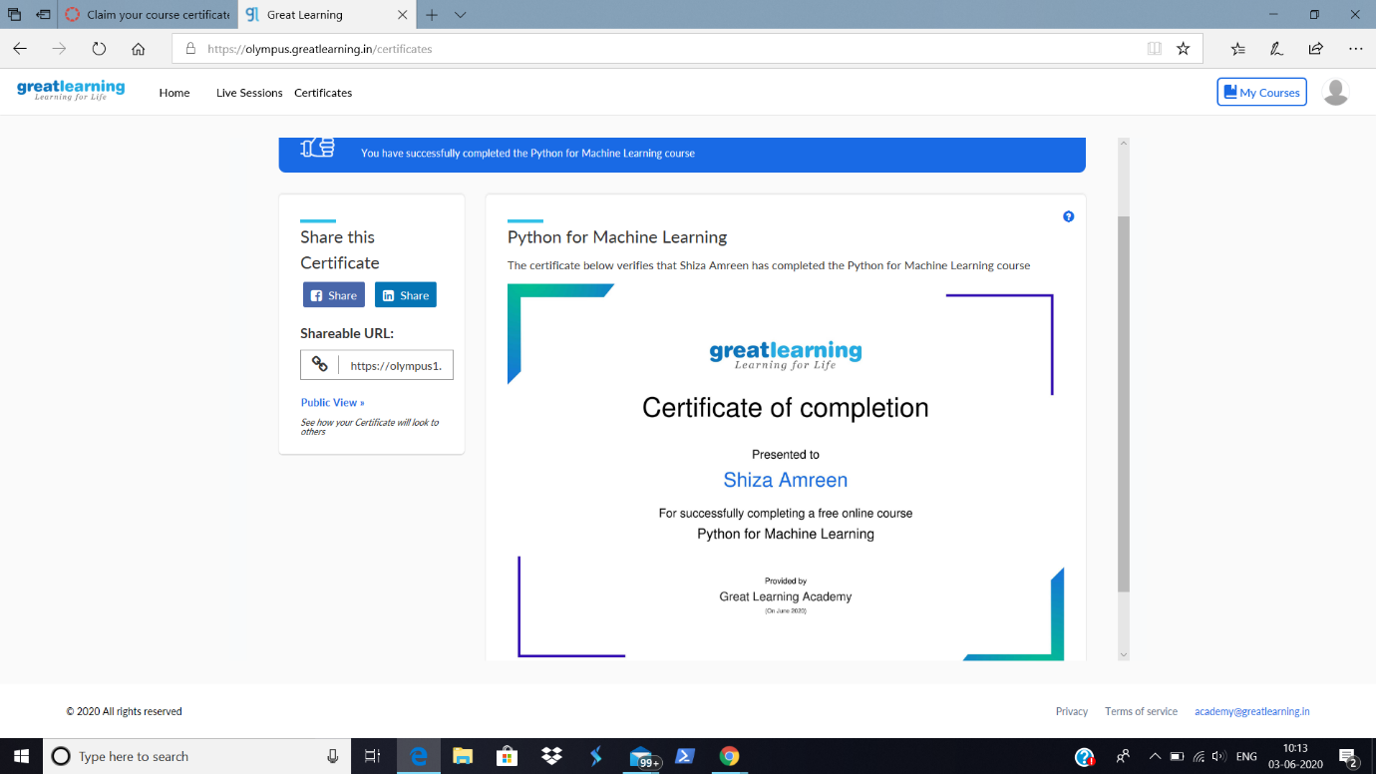

Coding Challenges Details:

**Problem Statement:** **Write a code segment in java to swap two numbers using call by object reference**

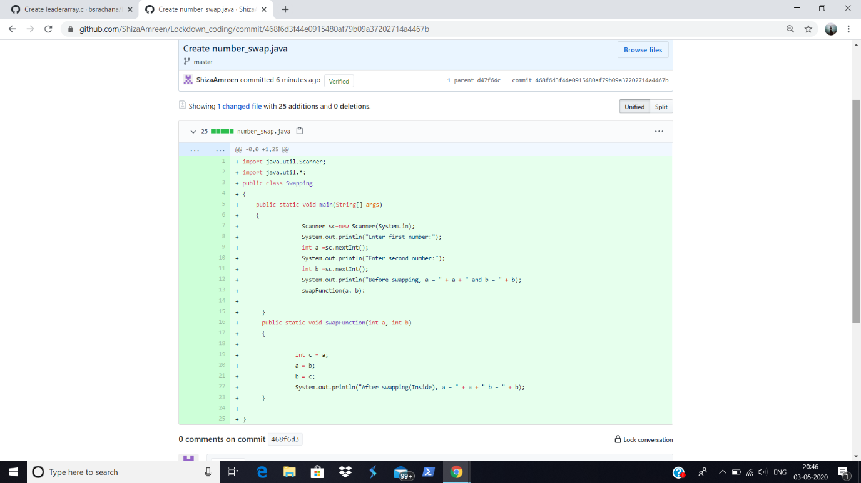

I have written the code for above problem statement and uploaded it in my github repository.

<https://github.com/ShizaAmreen/Lockdown_coding/commit/468f6d3f44e0915480af79b09a37202714a4467b>